

A Private Journey to
Australia, New Zealand & Singapore

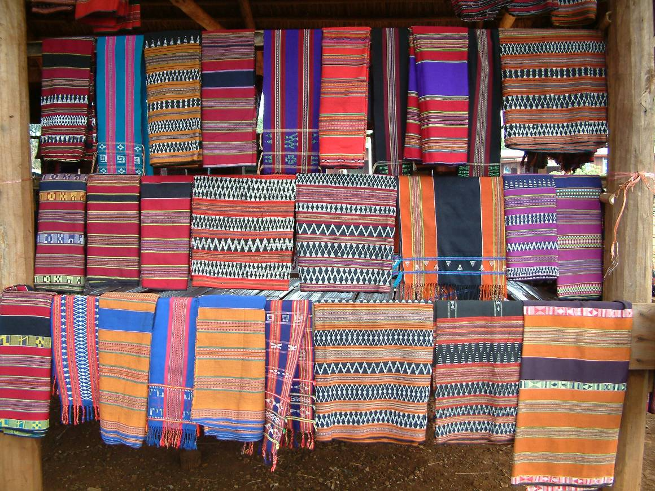

Specially prepared for

Dr Robin Crellin

7 February 2010 to 10 March 2010

QUICK REFERENCE ITINERARY

YOUR FLIGHT SCHEDULE

Date | Route | Flight No. | Check in | Depart | Arrive

* Arrival the following day

Flight Notes:

British Airways
The baggage weight limit on British Airways is either 1 or 2 pieces (subject to route – please check on www.ba.com) per person with each piece weighing no more than 23kg. British Airways charge a flat fee of £25 on any checked baggage weighing more than 23kg (51lbs). Any item weighing more than 32kg (70lbs) cannot be accepted as checked baggage.

British Airways
FREE CHECKED BAGGAGE ALLOWANCE:-
FIRST and Club World – 3 Bags
Club Europe and World Traveller Plus- 2 Bags
World Traveller and Euro Traveller – 1 Bag
Maximum dimensions per bag (H+W+L): 158cm (62in). Maximum weight per bag: 23kg (51lbs)*

HAND BAGGAGE
2 piece hand baggage allowance for all British Airways flights
- One standard-sized bag - maximum size of the bag must not exceed 56x45x25cm (22x17.5x9.85in) (including wheels, pockets and handles)
- In addition, one laptop sized bag, handbag or briefcase
- A 23kg(51lbs) maximum bag weight applies and you must be able to lift the bag into the overhead lockers in the aircraft cabin unaided.

Detailed TRIP Itinerary

TRIP PRICE
Estimated cost: | £14,590.00 per person  This price is guaranteed for the next 14 days. Please note after this period the price is subject to currency fluctuations.  This quote is the very best of hotels and is based on staying at:  - Metropole, Hanoi  - Violet Junk, Halong Bay  - Victoria, Sapa  - Le Residence, Hue  - Nam Hai, Hoi An  - Sheraton, Saigon  - Raffles, Phnom Penh  - Amansara, Siem Reap  - Amantaka, Luang Prabang  - Amanpuri, Phuket  To give an example, should you stay as above but change the Nam Hai for the Life Resort, the Amansara for the Hotel de la Piax and the Amanpuri for the Sarojin then the cost per person would be £10,335.00 (same inclusions/exclusions as below).

Includes:

Excludes:

Additional Information:
Notes: | The international air fares that we use are special discounted IT (inclusive tour) fares, which, whilst good value for money do carry strict booking conditions (e.g. have to be bought in conjunction with elements on the ground and are subject to certain restrictions, conditions and class availability).  This is a quotation only - no reservations have been made. The rates quoted are subject to the availability of all services, currency fluctuations, unexpected increases, written confirmation and Steppes Travel’s terms and conditions.  Please also note that these costs are based on 2009 and are subject to increase when the 2010 rates are published.  Optional Extras  Here are some suggestions of ways to enhance and therefore make your holiday even more special.  - Upgrade your hotel room  - Organise a personal shopper or expert guide  to show you around  - Organise a special celebration meal or unique activity  or excursion  - Pre-book valet, airport parking, airport hotels and  airport lounges.  If you wish to upgrade or pre-book any of the above options then please do contact us.

YOUR CONSULTANT

Donna Baker
Steppes East, {userX.position}

Donna Baker
Carole Williams
Asia, Sales Support
donna@steppestravel.co.uk
carole@steppestravel.co.uk

Tel: 01285 651010
Fax: 01285 885888

6 May 2010

CLIENT Test

Addressee: Mr P Wood
Address: Lower Long Barn
Cuttery Farm
East Allington
Totnes
Devon
United Kingdom
TQ9 7QD

